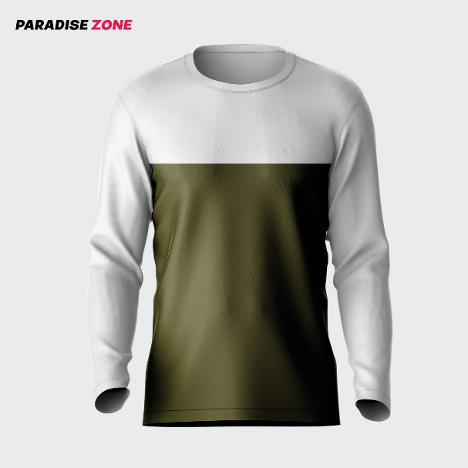

New Long Sleeves COntrast Panel Fashion Multi-colored Tshirt For Men

Product details of New Long Sleeves COntrast Panel Fashion Multi-colored Tshirt For Men

* New Long Sleeves COntrast Panel Fashion Multi-colored Tshirt For Men
* Fasionable export quality 100%soft and comfortable Men's Item
* T-Shirt style: Round Neck
* Fabric: Cotton Polister Mix JERSEY
* Full Colours:As Shown in picture
* Sizes:Medium,Large,XL
* Stylish wear for mens
* Wash at maximum 30 Degree
* Do not bleach
* Do not tumble dry
* Dry flat
* medium iron inside out

[object Object]

Specifications of New Long Sleeves COntrast Panel Fashion Multi-colored Tshirt For Men

* Brand

Paradise Zone

* SKU

379325265_PK-1872072914

* Apparel

Casual

* Age Range

Standard

* Fit Type

Regular

* Collar Type

O-Neck

* Clothing Style

Fast Fashion / High street

* Men's Trend

Korean,Party,Military,Retro & Vintage,Street Style,Preppy / Heritage,Rock and Roll

* Sleeves

Long Sleeve

* Clothing Material

Jersey

* Season

Summer

* Size Chart

MEDIUM CHEST 19.5 LENGHT 28 LARGE CHEST 20.5 LEGNTH 29 X LARGE CHEST 21.5 LENGHT 30